**Path Tracing & Irradiance Caching on the Cornell Box**

Vicky Li & Yifan Wang

**Motivation and Background**

The Cornell Box, often referenced in academic papers, textbooks, and tutorials, has become a significant benchmark in the field of computer graphics. The controlled environment it builds serves as a great testing scene for demonstrating various rendering algorithms and techniques. Similarly, path tracing is also a crucial rendering technique that is commonly used in computer graphics. It involves simulating the physical behavior of light rays as they interact with surfaces, creating visually accurate images by tracing the most probable paths of the light through the scene. Upon coming across the WebGL Path Tracing demonstration[1] made by Evan Wallace, we thought recreating his work would be a great way for us to both explore the intricacies of the Cornell Box as well as practice specific global illumination techniques we have learned in class.

While exploring the transition from OpenGL code to WebGL, we encountered various set up errors with Emscripten, a LLVM-to-WebAssembly compiler, and also realized a lack of OpenGL to WebGL resources, which caused us to reconsider our project direction. After consulting with TAs, we decided to pivot our project to instead render separate images of the scenes with two options of algorithms, path tracing, specifically the Monte Carlo algorithm mentioned in lecture, and irradiance caching. Similar to path tracing, irradiance caching is also a global illumination rendering technique. But it differs in the sense that it optimizes the rendering process by precomputing and storing irradiance values at specific points in the scene, allowing for efficient reuses of this information in the subsequent passes. In particular, we referenced an online tutorial[2] that explained the details of irradiance caching.

As before, we are still able to add and delete spheres and cubes from the image as well as change the material of the objects, but the components will no longer be able to be selected and moved. Instead, these changes to the scene will be able to be made as command line arguments, specified with different tags (similar to assignment 4). In the command line arguments, the users are also allowed to specify the type of rendering algorithm to generate the image with.

**Approach: Scene Creation**

We decided to keep our geometry relatively simple so that we could focus more of our time on our path tracing algorithm and connecting it to webGL. For the same reason, we decided to reuse the approach from assignment 4, using hittables, tracing components, and records to recognize intersections between rays and objects. This allowed us to reuse the hittable objects we’ve previously created. We realized that since we are only looking at the inside of the Cornell box, we can use 5-6 planes to create it, even if the planes are unbounded, making sure that the normals point inwards to display the inside of the box. In order to create the cube, we used a similar approach. However since the planes are unbounded and we now are looking from the outside, we updated the plane such that the camera only recognizes the plane if its outgoing ray intersects a specific region in the plane.

Each preset scene is its own scene node that would be added to the main scene node when its argument is called. We tried to stay true to the preset scenes we were referencing, in both the materials and positioning of each object. Through trial and error we tried to replicate his materials as much as we could. We also added the ability to add and remove (which can’t be demonstrated) objects by adding more nodes to the scene or removing the tracing component of existing nodes.

After we rendered the scene using our path tracing implementation, our Cornell box had a lot of repetitive textures and blurry colors that we were not expecting. We believed that this may have to do with the fact that we were using unbounded planes and thus we used the same approach we used for our cubes to only recognize intersections within a specific region, which fixed our scene.

**Approach: Path Tracing**

Fundamentally, path tracing is mathematical computation that calculates, for each pixel, the levels of luminescence across the entire image that arrives at a single point, that is, the origin of the object’s surface, which determines the color of that pixel. This calculation of the color is a combination of the direct illumination from the light source and the indirect illumination from light bouncing off of other objects in the scene (reduced by a factor with every bounce). If there is no hit at that pixel, it simply takes the background color.

For direct illumination, we adopted a similar approach to that of ray tracing, where the direct illumination is the sum of the ambient, diffuse, and specular shadings. For indirect illumination, if the number of bounces is greater than 0, then we sample a random direction in the hemisphere oriented by the hit normal. To sample the random direction, we generate a coordinate system based on the hit normal, sample a random point on the hemisphere, and translate that back to world coordinates using our local coordinate system. From here, we generate a ray in this direction and recursively trace the reflected light sources, decreasing the number of bounces with each iteration until it reaches 0.

The probability of this new ray is $\frac{1}{2π}$, and the BRDF of this ray is calculated by dividing the specular value of the material by π, assuming the Lambertian reflection. With the recursively calculated incoming light from the reflected rays, we can then apply the Rendering Equation as follows:

$L_{out}=∫_{Ω}L_{in}(l) f_{r}(x, l, v) cosθ dl+E_{out}(x, v)$

The integral portion of the Rendering Equation accounts for light from indirect illumination. Specifically, we can accumulate the indirect illumination by multiplying the reflection BRDF, the incoming light from the recursive bounces, and the cosine of the angle between the generated ray direction and the hit normal, and dividing this value by the probability of the new ray. We then multiply the indirect illumination by the specular value of the material as the contribution of indirect lighting should decrease with each recursive call.

Lastly, summing the direct and indirect illumination, we get the value of the color of that specific pixel. We used N=100 samples for each pixel of the image and took the average of the colors computed to calculate the final pixel color.

**Approach: Irradiance Caching**

With this approach, we store an array of cached entries containing a sample point’s hit position, hit normal, valid distance, and irradiance. We check for each pixel we want to evaluate irradiance, if there exists any valid entries and interpolate between them. If there isn’t, we calculate a new irradiance for this sample point and cache it.

To determine if an entry is valid for a sample point, we make two checks: the entry is not too far out of range, and that their normals are not too different. To determine the former, we calculate the valid range of a sample point to be the harmonic mean of the hit distance of the rays used for the estimator:

$H =N/\sum_{1}^{N}{}\frac{1}{d_{i}}$

where we used N=30 samples each with hit distance *d*. We used the Monte Carlo path tracing approach to sample these rays from the hit position. Using the harmonic mean distance means that cached points that “see” nearby geometry will have a smaller valid radii while points far away from visible geometry will have a larger radii. This also means that the cache entry distribution will be denser in corners and crevices and sparse in open space. This matches up well with where the indirect irradiance is likely to change the fastest. We’ve included images of our cached entries in our results section. To compare the normals, we just check that the dot product between the two vectors is greater than some arbitrary number we decided to be 0.314.

If there exists valid entry points, we take the weighted average of those points to be the irradiance for the sample point. The weight for a particular cache entry can be calculated in many ways but we used the weight proposed by Greg Ward in his ‘88 paper:

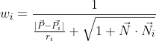

Although this function can be unbounded, we should never encounter this in our implementation as we make the check before adding a sample point to the cache. You can check to make sure the weights are above a certain threshold to be considered valid. Using these weights, we can then calculate the interpolated irradiance:

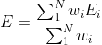

where *Ei* is the irradiance of the cached point.

If there are no existing valid entry points, we calculate the irradiance at the sample point using our path tracing algorithm.

**Results:**

Our algorithms had quite successful turnouts. Below are rendered images of our 4 presets scenes using path tracing and irradiance caching, respectively. We’ve also included images of our scenes with the cache entry positions shown as red dots.

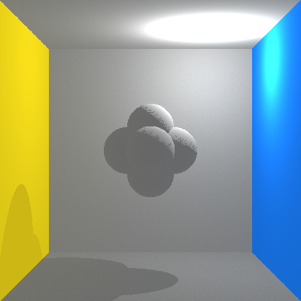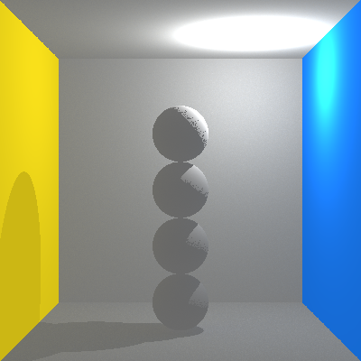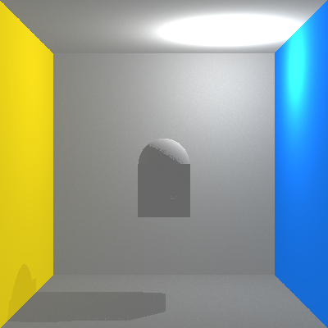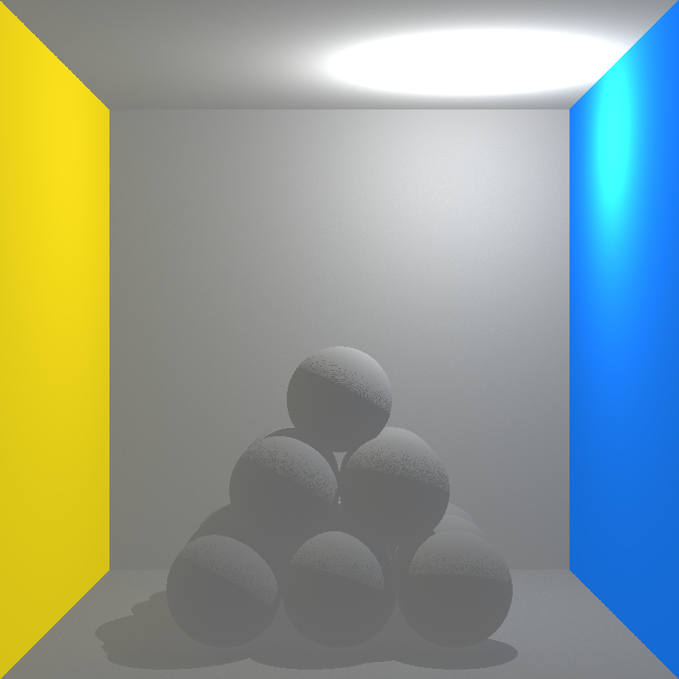

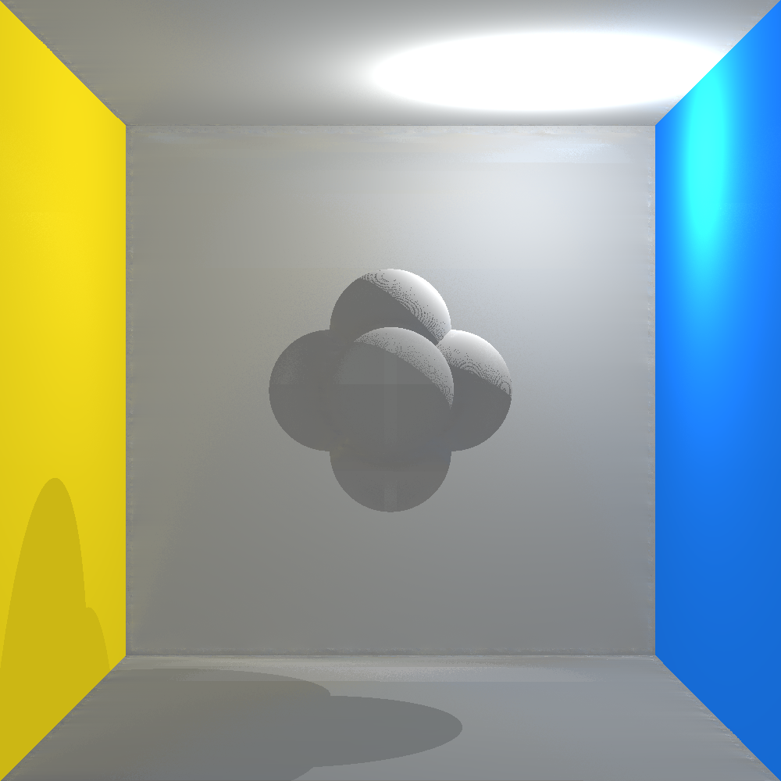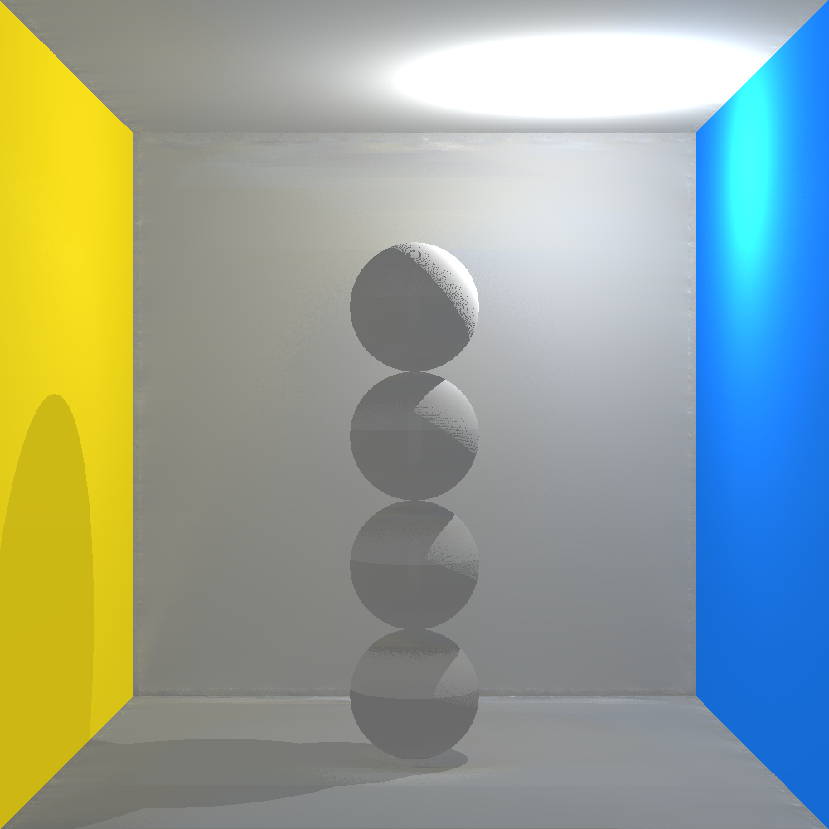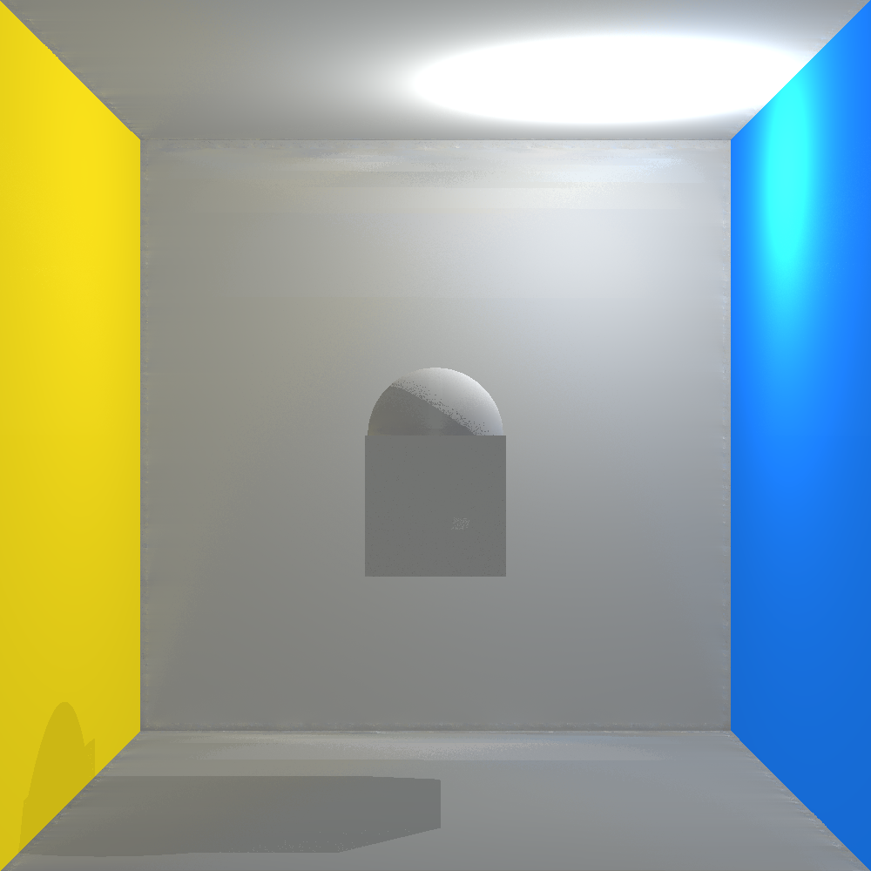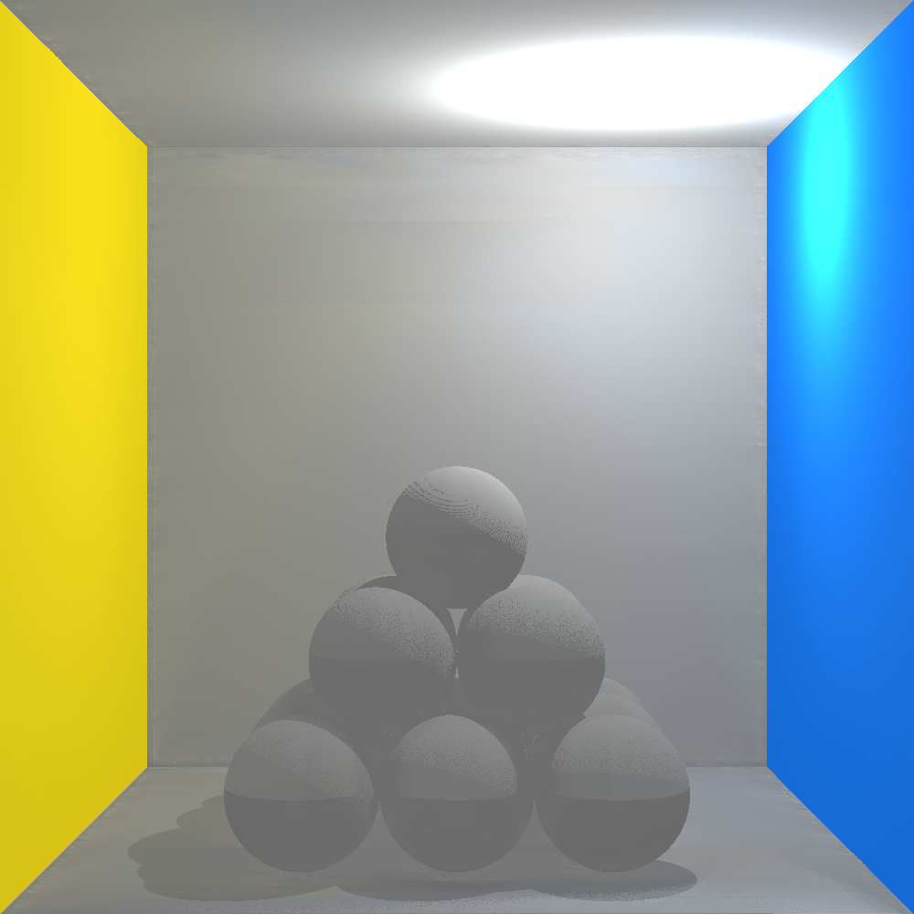

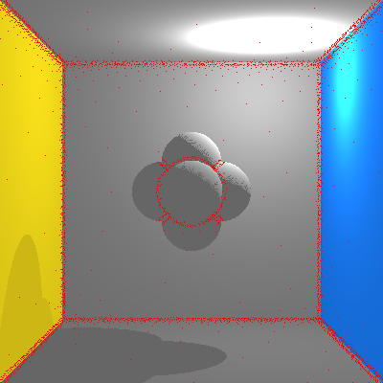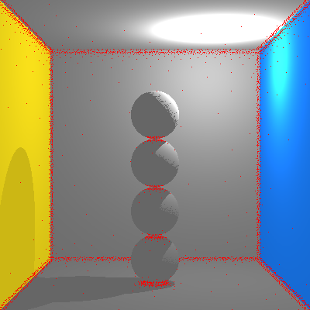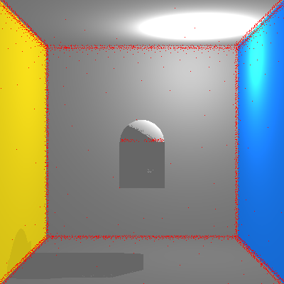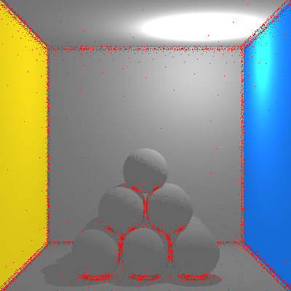

There is also a slight shift of yellow to blue on the back going from left to right that is due to the indirect illumination from the nearby colored walls. If we split and compare the left and right halves of the sphere pyramid image, we can see this pattern more visibly. 

Taking a look at their runtime, the average runtime for four 800x800 images of the preset scenes using the path tracing algorithm is 183.53 sec, while the average runtime using the irradiance caching algorithm is 44.53 sec. Here, we can see that irradiance caching indeed sped up the process as it took a little over 4x as fast.

Lastly, we also included some other functionalities that can be enabled using command line arguments, such as adding object, deleting object, and changing the object material to mirror. Below are the preset scenes with mirror material. (Note that the cube in scene 3 is entirely black; this is due to the fact that we did not create a 6th plane in the Cornell Box so that is what is being reflected in the mirror.)

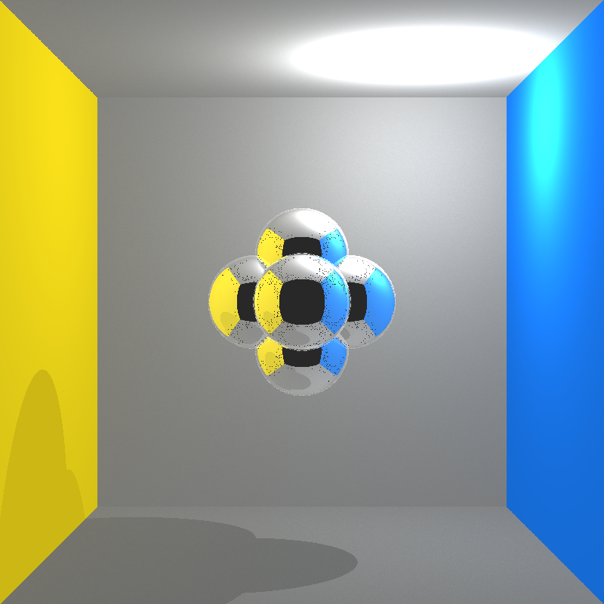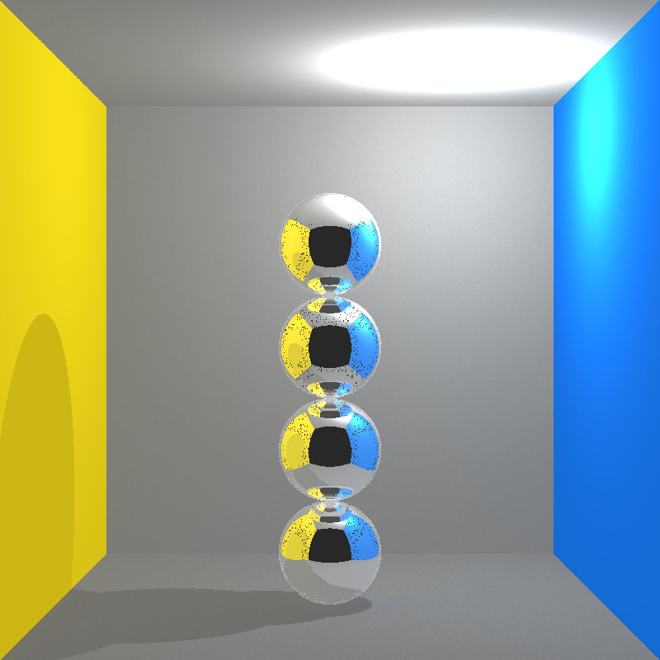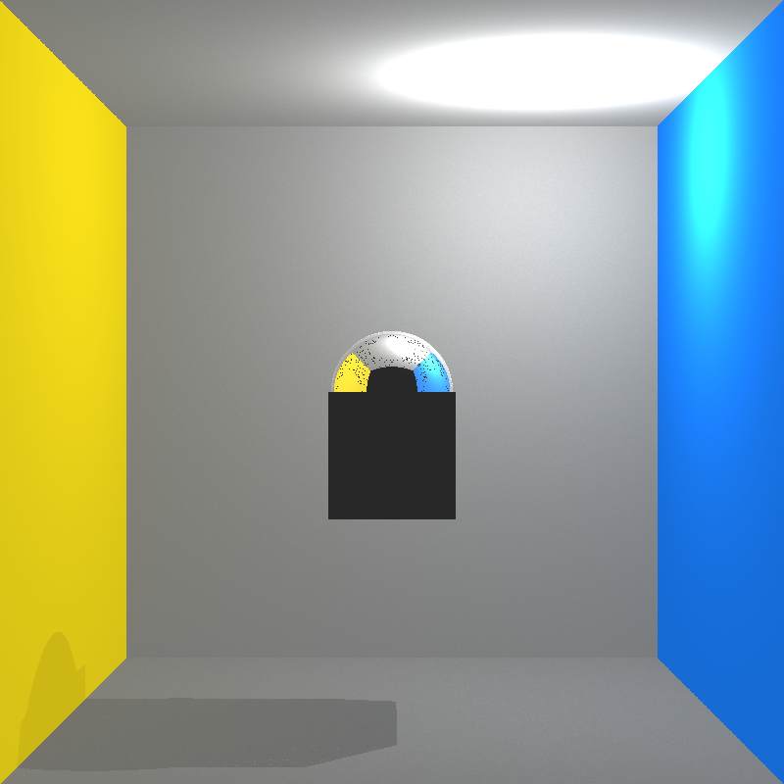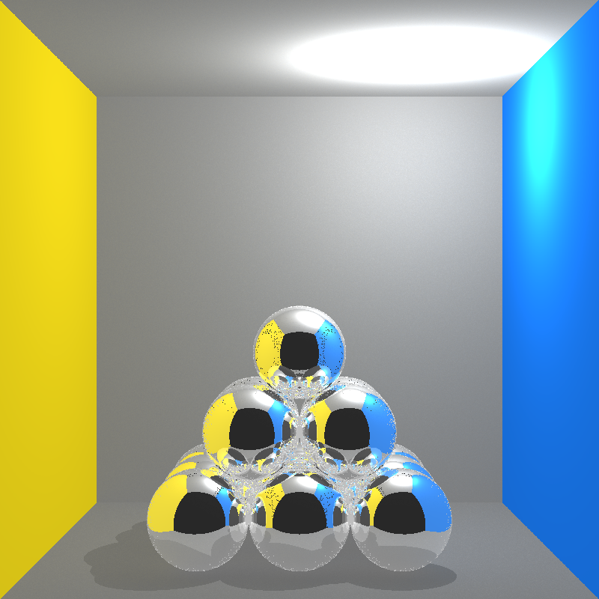

Here is also a live demonstration of calling the functionalities using command line (some parts in the middle where it was waiting for the image to render had been cut to shorten the video): <https://drive.google.com/file/d/1v2hJ3wMITec8XcC7Dzs8oA8zBd7g8jVG/view?usp=sharing>.

**Conclusion:**

Our initial plan was to recreate the WebGL Path Tracing page made by Evan Wallace. However, due to the limited resources for running OpenGL code through WebGL, we decided to switch our project to implement path tracing and irradiance caching, which builds from our path tracing algorithm, instead. We have created the Cornell box and added various preset scenes involving spheres and cubes to be rendered into an image. There is also the option to add and delete objects and to change the material by adding arguments when running the code. To render the scene, users have the option of using our path tracing algorithm or to use irradiance caching. Although not implemented in our project, one way to advance our irradiance caching implementation is to instead of taking a weighted sum of the irradiance caching entries, use a variation of the irradiance gradients to find the interpolated irradiance value. This would lead to less aliasing and make change in color smoother. Another would be to instead of using an arbitrary fixed value for comparing between the normal of a sample point and between an entry, to use a more meaningful value between each check. Similarly for path tracing, one way we can enhance the algorithm, though may not be necessary for Cornell Box scenes, is by implementing volumetric path tracing, which extends the algorithm by accounting for light scattering. This can be used to simulate photorealistic effects such as fire, explosion, or clouds.

1. <https://madebyevan.com/webgl-path-tracing/>
2. <https://www.rorydriscoll.com/2009/01/18/irradiance-caching-part-1/>